MCRO | Aspose Software Impossibility × Competency Statute Convergence
The Notice of Intent to Prosecute as Mechanism of Indefinite Control
Property | Value
Prepared by | Matthew David Guertin, Pro Se Defendant
Case Reference | State of Minnesota v. Guertin | 27-CR-23-1886
Court | Fourth Judicial District Court, Hennepin County
Report Date | March 2026
Data Source | Minnesota Court Records Online (MCRO) — Public Records
Corpus Size | 4,251 PDFs across 245 cases | 2016–2025
Database | PostgreSQL (Supabase) — custom forensic schema
Reproducibility | All findings query-reproducible. SHA256 hashes independently verifiable.

IMPORTANT DISCLAIMER
This report presents objective forensic data findings reproducible from the source database, combined with verbatim statutory text from Minnesota Statutes 611.40–611.59 and verbatim transcript excerpts from recorded court hearings.
This report does not assert conclusions about guilt, intent, motive, or criminal conduct by any party.
Where this report states that a document’s XMP creation date precedes the release date of the software identified in its producer string, this is a statement of mathematical fact, not an inference. A document cannot be created by software that does not yet exist. This requires no interpretive judgment.
Each finding is a documented pattern that warrants independent expert examination. Statutory text is quoted verbatim from the Minnesota Revisor’s Office. Transcript excerpts are verbatim from recorded hearings in case 27-CR-23-1886.

EXECUTIVE SUMMARY
• 27 documents in the MCRO corpus carry the producer string “Aspose.Words for .NET 14.2.0.0,” identifying them as created by a specific version of commercial document-generation software released in February 2014.
• 7 of these 27 documents have XMP creation dates before February 2014 — meaning they claim to have been created by software that did not yet exist. This is a temporal impossibility requiring no interpretive judgment.
• 17 documents share a single frozen creation timestamp: February 26, 2019, 15:05 UTC. All 17 are “Notice of Intent to Prosecute” filings for 14 different defendants, filed across a span of 1,056 days (2.9 years).
• 18 of the 27 Aspose documents (66.7%) are “Notice of Intent to Prosecute” filings — the specific filing type that, under MN Statute 611.45 Subd. 3, prevents the dismissal of criminal charges against defendants found incompetent to stand trial.
• Without a “Notice of Intent to Prosecute,” charges against incompetent defendants MUST be dismissed. With one, prosecution can be extended 1–10 years. With continued supervision under 611.49, felony dismissal requirements can be eliminated entirely.
• 48 “Notice of Intent to Prosecute” filings exist corpus-wide. 18 (37.5%) were generated by Aspose software with fabricated creation metadata. These 18 filings affect 15 defendants.
• Defense counsel Raissa Carpenter explicitly told defendant Guertin, on the record (October 7, 2025): “If they file a notice of intent to continue to prosecute you then they can do it indefinitely until a judge agrees to dismiss it in the interests of justice.”
• The Minnesota competency statute (611.40–611.59) — 23 pages governing forced medication, indefinite supervision, and suspension of criminal proceedings — contains the word “medication” 59 times and “neuroleptic” 37 times. The words “rights,” “due process,” “constitutional,” and “dangerous” appear zero times.
• All 27 Aspose documents also carry the iText® 7.1.16 “Minnesota Judicial Branch; licensed version” pipeline stamp, confirming they were processed through the official court e-filing system (which stamps 97.6% of the corpus).
• The single most extreme data point: a “Dismissal by Prosecuting Attorney” for Travis McGIRL (27-CR-20-20866), filed September 30, 2025, carries an XMP creation date of September 9, 2013 — a gap of 4,404 days (12.1 years) and 5 months before the software existed.
• 22 of 22 Aspose defendants (100%) have Rule 20 competency events in the docket. 14 of 22 (63.6%) have a Finding of Incompetency and Order in their case files. 14 of 22 (63.6%) have ESolutions Development Certificate Authority digital signatures on their documents.
• The person declared legally incompetent by this system — Matthew Guertin, holder of US Patent 11,577,177, CEO of InfiniSet, Inc. — built the 4,251-document forensic database that identified the fabricated creation dates on the filing type that enables indefinite prosecution of defendants declared incompetent.

Corpus Overview
Metric | Value | Notes
Total PDFs Analyzed | 4,251 | All bear valid MCRO cryptographic watermark
Aspose Cohort | 27 | Aspose.Words for .NET 14.2.0.0
Pre-Release Impossibilities | 7 | Creation dates before Feb 2014
Frozen Timestamp Clusters | 3 | 17 + 4 + 2 documents
Notice of Intent to Prosecute (Aspose) | 18 | 66.7% of Aspose cohort
Notice of Intent to Prosecute (corpus-wide) | 48 | Across 43 cases, 30 defendants
Cases with Incompetency Finding (CR) | 131 of 217 | 60.4%
iText Pipeline Coverage | 4,148 of 4,251 | 97.6%
Defendants Affected by Aspose NIP | 15 | With fabricated creation metadata

 | KEY METRICS
7 | documents created by software that did not yet exist
17 | “Notice of Intent to Prosecute” documents sharing one fabricated timestamp
0 | times the word “rights” appears in the 23-page competency statute
4,404 | days (12.1 years): longest gap between fabricated creation date and filing date
1,056 | days (2.9 years): filing span of 17 frozen-timestamp NIP documents
100% | of Aspose defendants have Rule 20 competency events
38+ | months: Guertin’s ongoing Rule 20 proceedings
4,251 | documents in database built by person declared incompetent

TECHNICAL BACKGROUND

What Is Aspose.Words?
Aspose.Words for .NET is a commercial software library published by Aspose Pty Ltd. It enables developers to create, modify, and convert Microsoft Word documents programmatically — without requiring Microsoft Office. It is used in enterprise document automation, template-based generation, and batch processing.
When Aspose.Words creates or modifies a document that is subsequently converted to PDF, it embeds its identity in the PDF’s XMP metadata “producer” field. All 27 documents in this cohort carry the producer string:
Aspose.Words for .NET 14.2.0.0; modified using iText® 7.1.16 ©2000-2021 iText Group NV (Minnesota Judicial Branch; licensed version)

The Version Numbering System
Aspose uses a YY.M (year.month) version numbering scheme. Version 14.2 corresponds to February 2014. This version was released in February 2014. Any document that carries this producer string was necessarily created on or after February 2014.
The logical impossibility: If a PDF’s XMP creation date is before February 2014, but its producer string identifies Aspose.Words 14.2.0.0 as the creating software, then the creation date is fabricated. The software did not exist at the claimed creation time. A document cannot be created by software that does not yet exist.

What Is XMP Metadata?
XMP (Extensible Metadata Platform) is an ISO standard (ISO 16684) for embedding metadata within digital files. In PDFs, XMP metadata includes creation date, modification date, creator tool, and producer — fields set automatically by the software that creates or processes the document. These fields are embedded in the file’s binary structure and persist through standard file operations.

The iText Pipeline Stamp
All 27 Aspose documents also carry a secondary producer identifier: “itext® 7.1.16 ©2000-2021 iText Group NV (Minnesota Judicial Branch; licensed version).” This indicates the document passed through the court’s official e-filing pipeline, which uses iText 7.1.16 to process and watermark documents. This pipeline stamps 97.6% of the 4,251-document corpus (4,148 documents). The presence of this stamp on the Aspose documents confirms they were not rogue uploads — they entered the official system.

STATUTORY BACKGROUND
Minnesota Statutes 611.40–611.59: Competency Proceedings
Minnesota’s competency statute governs the proceedings when a criminal defendant’s competency to stand trial is at issue. The statute was substantially revised in 2022 (Laws 2022, c. 99) and amended in 2023 and 2025. The following excerpts are quoted verbatim from the current statutory text (MN Statutes 2025, as published by the Minnesota Revisor of Statutes).

The Incompetency Standard (611.42, Subd. 1)
“A defendant is incompetent and shall not plead, be tried, or be sentenced if, due to a mental illness or cognitive impairment, the defendant lacks the ability to: (1) rationally consult with counsel; (2) understand the proceedings; or (3) participate in the defense.”

The Notice of Intent to Prosecute (611.45, Subd. 3)
This is the pivotal statutory mechanism. Once a defendant is found incompetent, charges must be dismissed — unless the prosecutor files a “Notice of Intent to Prosecute.” The timelines:
Misdemeanors (non-targeted): Charges must be dismissed immediately upon incompetency finding.
Targeted misdemeanors/gross misdemeanors: Charges must be dismissed 30 days after incompetency finding, unless the prosecutor files a written notice of intent to prosecute. If filed: dismissal within 1 year (targeted misdemeanor) or 2 years (gross misdemeanor).
Felonies: Charges must be dismissed 3 years after incompetency finding, unless the prosecutor files a written notice of intent to prosecute. If filed: dismissal within 5 years, or 10 years if maximum sentence ≥ 10 years.
Exception (611.45, Subd. 3(d)): “The requirement that felony charges be dismissed under paragraph (c) does not apply if: (1) the court orders continuing supervision or monitoring pursuant to section 611.49.”
In plain terms: The “Notice of Intent to Prosecute” is the single document that stands between an incompetent defendant and the dismissal of their charges. Without it, the case ends. With it, the case continues for years. And if the court orders continued supervision under 611.49, the felony dismissal requirement disappears entirely.

The Circular Architecture
The statute creates a self-referencing loop once activated:
1. Defendant charged with any crime (611.42 Subd. 1)
2. Court, prosecutor, OR defense counsel raises competency — defendant’s consent not required (611.42 Subd. 3)
3. Court orders competency examination (611.43)
4. Defendant is presumed incompetent unless found competent by preponderance of evidence (611.44 Subd. 4 — burden reversed)
5. Criminal proceedings suspended — defendant cannot plead, be tried, or be sentenced (611.42 Subd. 1)
6. Court orders defendant to competency attainment program — including jail-based programs with mandatory medication capability (611.46, 611.59 Subd. 3)
7. Notice of Intent to Prosecute filed — charges NOT dismissed (611.45 Subd. 3)
8. Review hearings every 6–12 months (611.46 Subd. 6) — if still incompetent, loop to Step 6
9. If unlikely to attain competency: continued supervision up to 10 years or indefinitely for certain charges (611.49 Subd. 3)
10. Court can authorize involuntary neuroleptic medication for renewable 1-year terms (611.47)
The catch: The defendant cannot litigate the underlying charges while incompetent (611.42 Subd. 1). The defendant cannot waive counsel (611.42 Subd. 2). The defendant can be excluded from their own hearing (611.50 Subd. 3). Medical professionals can request that hearings proceed without the defendant (611.50 Subd. 2). Cooperation channels the defendant into the medication/programming loop; but refusal to cooperate cannot be used against them (611.49 Subd. 1(b)) — leaving the defendant with no path out.

Statute Word Frequency Analysis
An analysis of the full statutory text of MN 611.40–611.59 reveals the following word frequencies:
Term | Occurrences | Context
“medication” | 59 | Governing forced medication procedures
“neuroleptic” | 37 | Specifying the class of psychiatric drugs
“mental illness” | 19 | Defining the triggering condition
“administration of neuroleptic medication” | 16 | Procedural authorization
“mental health” | 15 | General references
“authorized/authorization” | 10 | Granting authority for medication/supervision
“dangerous” | 0 | NEVER APPEARS
“due process” | 0 | NEVER APPEARS
“rights” | 0 | NEVER APPEARS
“constitutional” | 0 | NEVER APPEARS
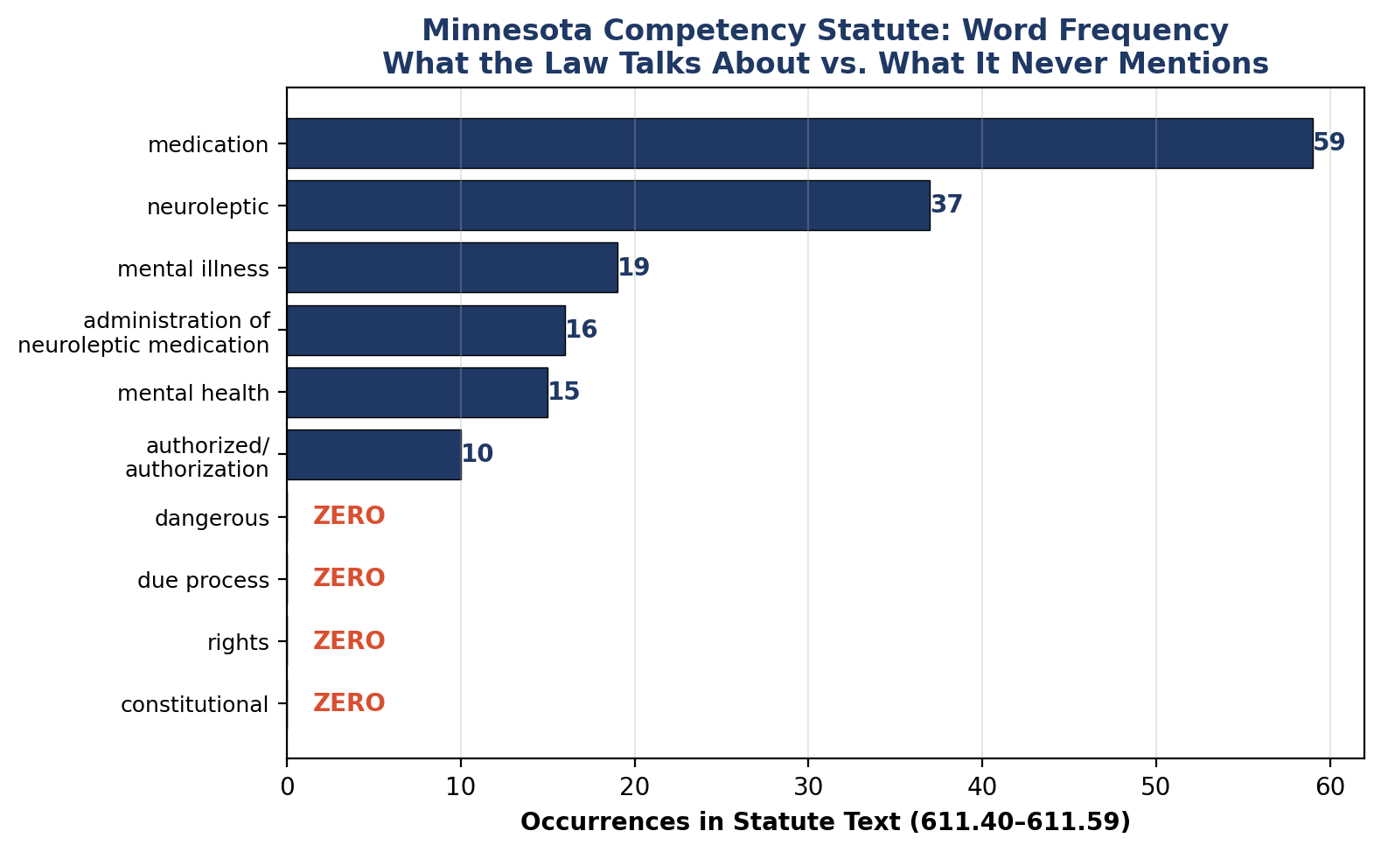

METHODS
All quantitative findings in this report are derived from SELECT-only queries against the MCRO forensic PostgreSQL database (Supabase project ibfmjtwahkwqzcmeyqii, region us-west-2). No data was modified during analysis. Every statistic is reproducible from the SQL queries provided in the Appendix.
Aspose cohort identification: Documents were identified by filtering the children.metadata__xmp_producer field for the string “Aspose.” All 27 matching documents share the identical producer string “Aspose.Words for .NET 14.2.0.0; modified using iText® 7.1.16.”
Temporal impossibility determination: The Aspose.Words 14.2.0.0 release date (February 2014) was established from Aspose’s public release history. Any document with metadata__xmp_create_date before February 1, 2014 whose producer string identifies Aspose 14.2.0.0 has a temporally impossible creation date.
Frozen timestamp detection: Creation dates were truncated to the minute using date_trunc(‘minute’, metadata__xmp_create_date) and grouped. Clusters of 2 or more documents sharing the same truncated creation timestamp were flagged.
Pipeline analysis: Defendants with both “Finding of Incompetency and Order” and “Notice of Intent to Prosecute” filing types were identified through JOIN queries on the children table. Cross-dimensional overlap was computed against ESolutions signature, IronPDF, and Rule 20 event populations.
Statutory analysis: The full text of MN Statutes 611.40–611.59 was obtained from the Minnesota Revisor of Statutes. Word frequencies were computed from the provided text. All quoted language is verbatim.
Transcript analysis: Verbatim excerpts were extracted from JSON-formatted hearing transcripts for case 27-CR-23-1886, recorded on April 29, 2025, October 7, 2025, and November 18, 2025.
Tables and views used: children, children_signatures_full_report, children_objects, case_registry, parents_case_events, parents, parents_case_events_judicial_officers, parents_case_events_examiners.

FINDINGS

Finding 1: The Aspose Software Version Temporal Impossibility

Background
When Aspose.Words for .NET creates or modifies a document, it embeds its version identifier in the PDF’s XMP producer field. Version 14.2.0.0 uses Aspose’s standard YY.M numbering scheme, where “14.2” designates a February 2014 release. A document carrying this producer string was necessarily created or processed by this software on or after its release date.

Findings
The MCRO corpus contains 27 documents with the Aspose.Words for .NET 14.2.0.0 producer string, spanning 25 case numbers and 22 distinct defendants with 6 filing types. Filing dates range from October 9, 2018 to September 30, 2025. (See Appendix A1.)
7 of these 27 documents have XMP creation dates before February 2014 — the release month of the identified software version. These 7 documents are temporal impossibilities:
Defendant | Case ID | Filing Type | Filing Date | XMP Create Date | Days Before Release | Gap (days)
PRIEST JESUS | 27-CR-22-4239 | Notice of Motion and Motion | 2024-01-08 | 2013-08-14 | 168 | 3,799
PRIEST JESUS | 27-CR-22-4239 | Order-Other | 2024-01-09 | 2013-08-14 | 168 | 3,800
CASPER VUONG | 27-CR-20-23521 | Dismissal by Prosecuting Atty | 2023-06-13 | 2013-09-09 | 144 | 3,564
ABDINOUR ALASOW | 27-CR-22-23317 | Dismissal by Prosecuting Atty | 2023-09-13 | 2013-09-09 | 144 | 3,656
MARVAL BARNES | 27-CR-21-6229 | Dismissal by Prosecuting Atty | 2023-09-28 | 2013-09-09 | 144 | 3,671
Travis McGIRL | 27-CR-20-20866 | Dismissal by Prosecuting Atty | 2025-09-30 | 2013-09-09 | 144 | 4,404
RASHEED RICHARDSON | 27-CR-20-26577 | Prosecutor’s Notice/Request | 2023-08-22 | 2013-11-25 | 67 | 3,557

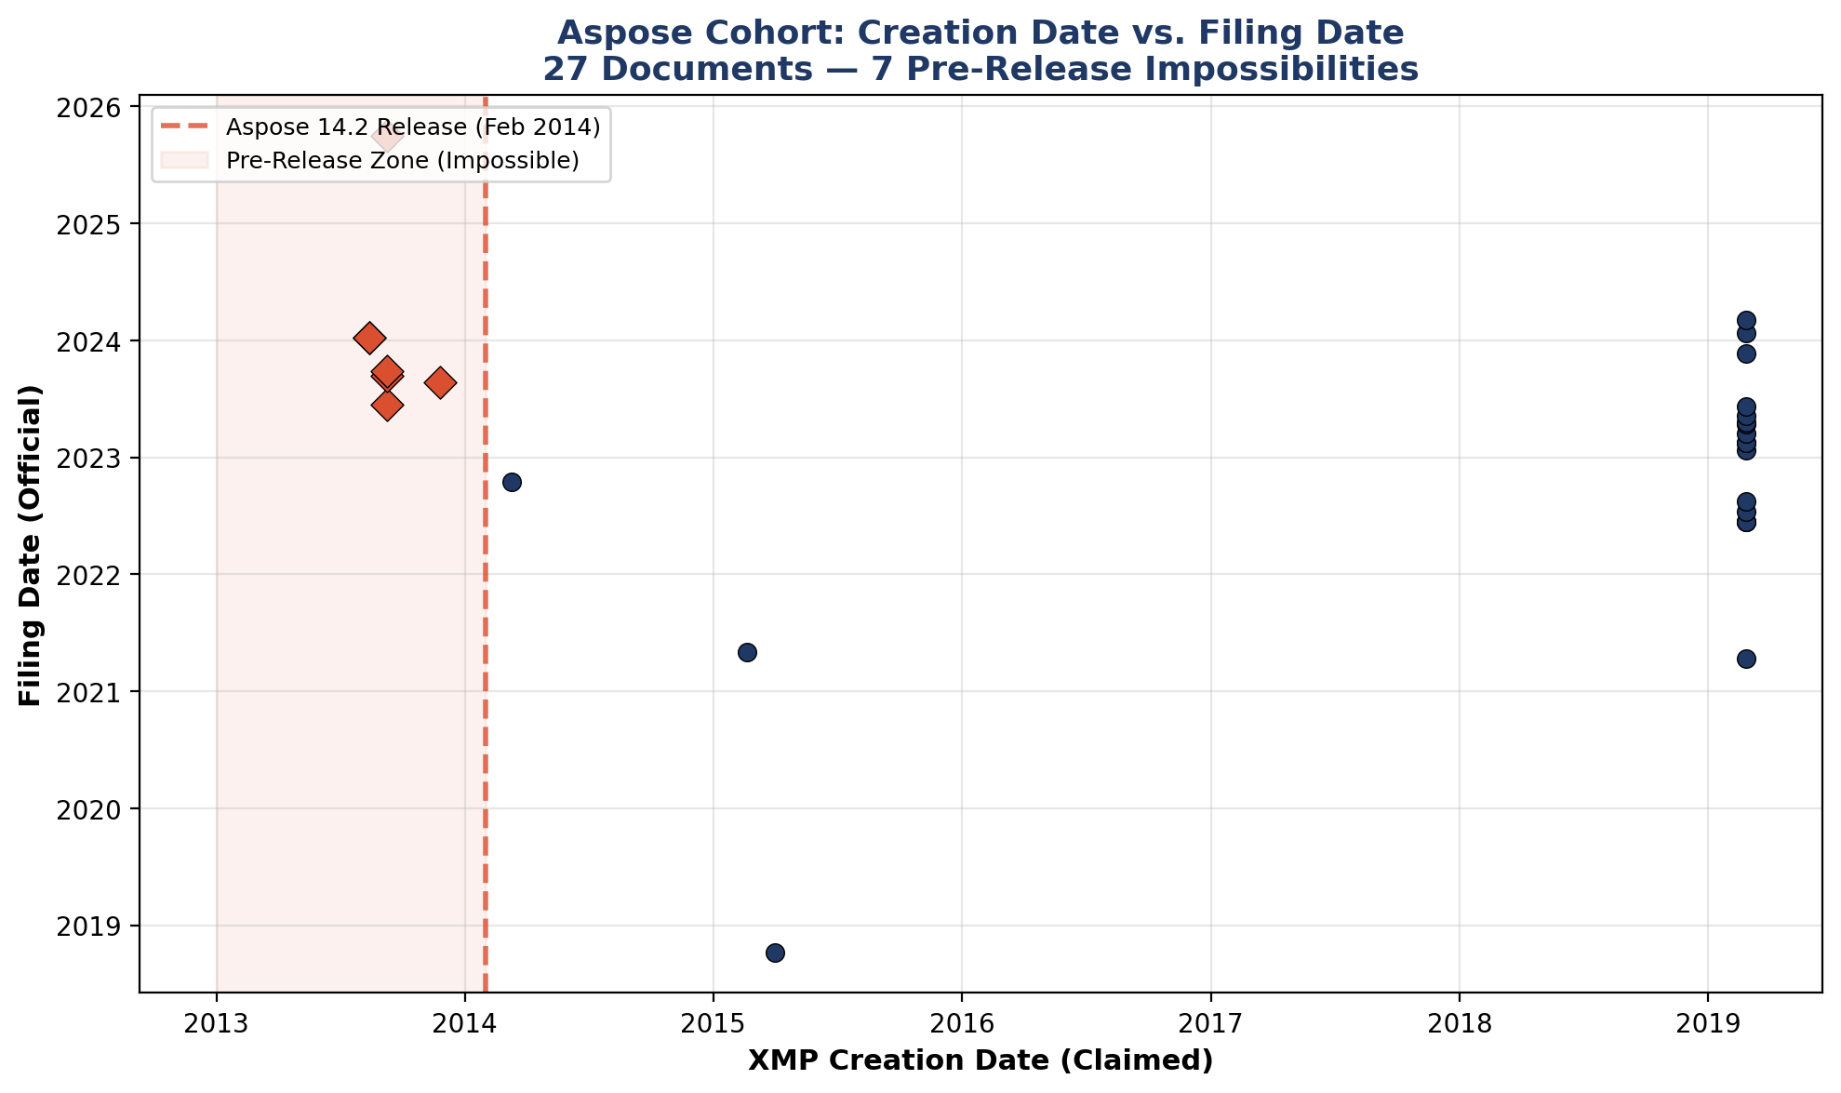
Significance
A document cannot be created by software that does not yet exist. These 7 creation dates are not edge cases, rounding errors, or timezone discrepancies. The earliest (August 14, 2013) precedes the software release by 168 days. The document was filed in January 2024 — 3,799 days after its claimed creation date. No benign explanation — clock drift, template reuse, timezone error — accounts for pre-release creation dates, because all such explanations presuppose the existence of the software at the time of creation.

Connecting Context
This finding establishes the foundational forensic fact: the creation dates in the Aspose cohort are fabricated. This fact underpins all subsequent findings. The significance of Findings 2–3 depends on this: if the timestamps are genuine, the frozen clusters are coincidences; if fabricated, they reveal batch-processing patterns operating at industrial scale.

Finding 2: The Frozen Fabrication Clock — 17 Identical Timestamps Across 2.9 Years

Background
When documents are created individually — as a “Notice of Intent to Prosecute” would be, since each names a specific defendant and represents a specific prosecutorial decision — their creation timestamps reflect the distinct moments of their creation. Identical creation timestamps across multiple documents for different defendants indicate batch processing, template reuse, or automated generation.

Findings
The 27 Aspose documents cluster into 3 frozen timestamp groups (documents sharing a creation timestamp to the minute) plus 4 singletons (see Appendix A2):
Frozen Timestamp (UTC) | Documents | Defendants | Cases | Filing Types | Filing Span
2013-08-14 20:45 | 2 | 1 | 1 | Motion, Order | 1 day
2013-09-09 13:50 | 4 | 4 | 4 | Dismissal by Prosecuting Atty | 840 days
2019-02-26 15:05 | 17 | 14 | 17 | Notice of Intent to Prosecute | 1,056 days
Cluster 3 is the critical finding: 17 “Notice of Intent to Prosecute” filings for 14 different defendants, filed across a span of 1,056 days (April 13, 2021 to March 4, 2024), all claim to have been “created” at the same instant: February 26, 2019 at 3:05 PM UTC.
These are not generic forms. Each “Notice of Intent to Prosecute” names a specific defendant. Each represents a specific prosecutorial decision about a specific person’s liberty. 17 such decisions, for 14 different human beings, across nearly 3 years, all share one fabricated creation timestamp.
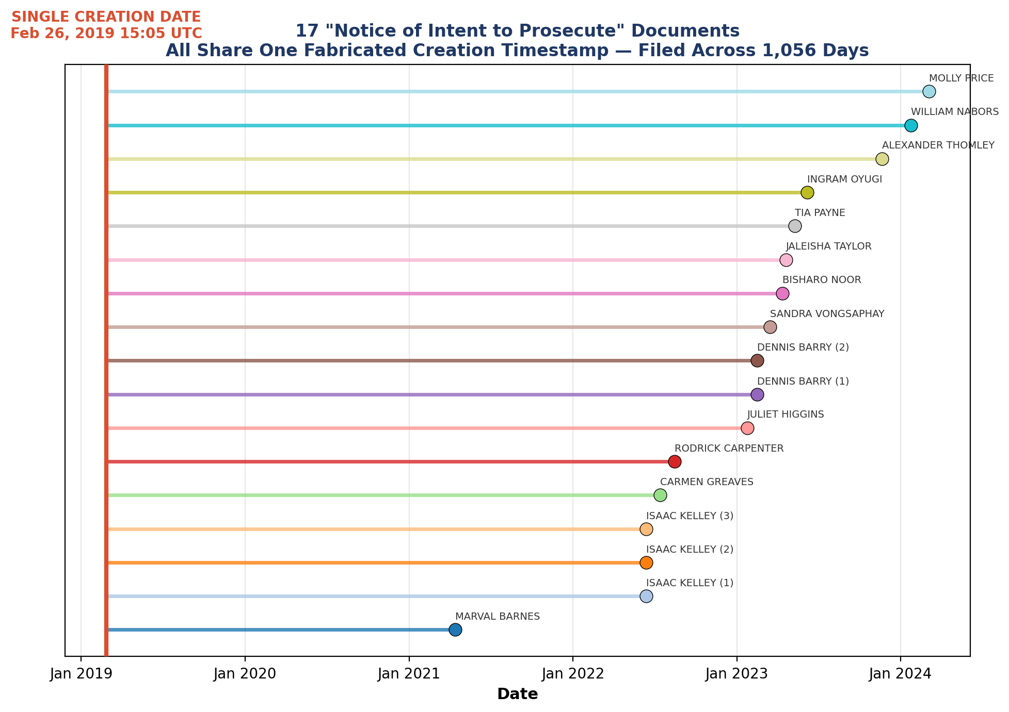

Significance
The frozen timestamp pattern is consistent with batch-generated documents produced from a template at a single point in time, then filed individually over subsequent years as needed. Combined with the pre-release impossibility (Finding 1), which establishes that the creation dates are fabricated, Cluster 3 demonstrates that the document type preventing charge dismissal and enabling indefinite prosecution was produced through automated batch processing.

Connecting Context
Finding 3 establishes the legal significance of “Notice of Intent to Prosecute” under Minnesota statute. Finding 4 documents a recorded statement confirming that this filing type enables indefinite prosecution. Together, they form a chain: fabricated creation dates (Finding 1) → batch-produced documents (Finding 2) → the statutory mechanism that prevents charge dismissal (Finding 3) → confirmed indefinite prosecution capability (Finding 4).

Finding 3: The Filing Type That Controls Freedom — “Notice of Intent to Prosecute” Under MN 611.45

Background
This finding requires no SQL queries. It is a statutory analysis establishing the legal significance of the specific filing type that dominates the Aspose cohort.

Findings
18 of 27 Aspose documents (66.7%) are “Notice of Intent to Prosecute” filings. This filing type is defined by MN 611.45, Subdivision 3, as the document the prosecutor must file to prevent automatic charge dismissal when a defendant is found incompetent.
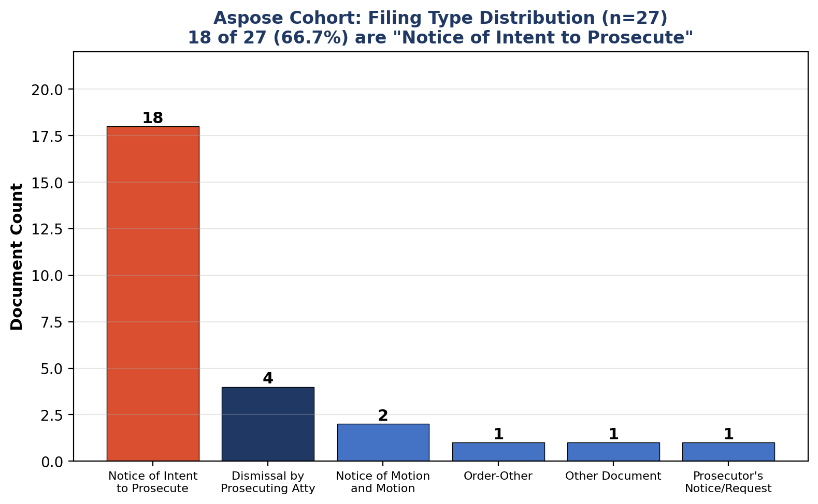
The statutory framework: Without a “Notice of Intent to Prosecute,” charges must be dismissed. With one:
• Targeted misdemeanors: prosecution extends up to 1 year
• Gross misdemeanors: prosecution extends up to 2 years
• Felonies: prosecution extends up to 5–10 years
• Felonies with continued supervision (611.49): dismissal requirement eliminated entirely

Significance
18 of these levers — the documents that prevent charge dismissal and enable indefinite prosecution — carry fabricated creation dates. 17 share the same impossible frozen timestamp. They were filed for 15 different defendants across nearly 3 years. And they were produced by software that did not exist at their claimed creation date.

Connecting Context
The Aspose cohort is not randomly distributed across filing types. It is concentrated in the single filing type that serves as the statutory gateway to indefinite state control over defendants found incompetent. 18 of 27 documents (66.7%) are this one type. The next most frequent type (Dismissal by Prosecuting Attorney) accounts for only 4 of 27 (14.8%).

Finding 4: The Recorded Statement — “They Can Do It Indefinitely”
Background
The following exchange was recorded during a hearing in case 27-CR-23-1886 (State v. Guertin) on October 7, 2025, before Court Referee Lori Skibbie. Defense counsel Raissa Carpenter was speaking to defendant Matthew Guertin about the Rule 20 process.

Findings
Clip 001 — Carpenter to Guertin (October 7, 2025):
GUERTIN: “How long does this shit go on for? Like how...when does this end?”
CARPENTER: “There is for most cases it’s about a three year timeline from when you’re first found not competent unless they file a notice of intent to prosecute you. If they file a notice of intent to continue to prosecute you then they can do it indefinitely until a judge agrees to dismiss it in the interests of justice.”
Clip 005 — Guertin’s response (same hearing):
“Yeah, I want the — I have job offers. I have stuff going on. I’m trying to get this shit over with. It’s my entire goal, and it’s never-ending [...] it’s going on 32 months of this shit.” [...] “I just want — I want closure, right? Because that doesn’t seem unreasonable to want to put this behind me and move on with my life.”
Clip 050 — Judge Hudleston (April 29, 2025), characterizing Guertin’s filings:
“The expressions in the motion to dismiss, again, over 50 pages, have repeated assertions over and over and over and over again citing coordinated campaigns, intentional manipulation of the system to paint you as incompetent to proceed in your criminal case with the motive, I think, apparently being to cover up patent theft.”
Clips 002–003 — Carpenter to Guertin (November 18, 2025):
“Any of that stuff while you are incompetent [...] we can’t have a substantive legal proceeding while you are found not competent because it has been determined on the record that you don’t have the ability to engage in those things so we can’t do them.”

Significance
The defendant is told directly by his own attorney that a “Notice of Intent to Prosecute” enables indefinite prosecution. This is the same filing type that constitutes 66.7% of the Aspose-fabricated document cohort. The defendant then attempts to raise concerns about fabricated court records and is told he cannot litigate while declared incompetent — the very status that the fabricated “Notice of Intent to Prosecute” documents serve to perpetuate across the corpus.

Connecting Context
Finding 5 examines the statute’s circular architecture that makes this dynamic structural rather than incidental. Finding 9 presents the specific timeline of the defendant who discovered these patterns.

Finding 5: The Competency Statute’s Circular Architecture
Background
This finding examines the structural properties of MN 611.40–611.59 as a self-referencing legal system. It requires no database queries; it is a textual analysis of the statute itself.

Findings
The statute creates an inescapable procedural loop once activated. The critical features:
Entry is low-barrier: Any crime from misdemeanor to felony. Competency can be raised by the court, the prosecutor, or defense counsel. The defendant’s consent is not required (611.42 Subd. 3).
The burden is reversed: “The defendant is presumed incompetent unless the court finds by a preponderance of the evidence that the defendant is competent” (611.44 Subd. 4).
Self-representation is blocked: “A defendant must not be allowed to waive counsel if the defendant lacks ability to: [...] appreciate the consequences of proceeding without counsel” (611.42 Subd. 2).
Litigation is suspended: Criminal proceedings are suspended. The defendant cannot plead, be tried, or be sentenced (611.42 Subd. 1).
The defendant can be excluded: “The court [...] may exclude or excuse a defendant who is seriously disruptive, refuses to participate, or who is incapable of comprehending and participating in the proceedings” (611.50 Subd. 3). A medical professional can request that the hearing proceed without the defendant (611.50 Subd. 2).
Forced medication is authorized: The court can authorize involuntary neuroleptic medication for renewable one-year terms (611.47). If physical force is required, injectable medications must be used (611.47 Subd. 7).
Cooperation is a trap: A defendant’s refusal to cooperate “cannot” be used to find them unlikely to attain competency (611.49 Subd. 1(b)). But cooperation channels them into the medication and programming loop. Neither path leads to exit.

Significance
The statute contains 59 references to “medication,” 37 to “neuroleptic,” and zero to “rights,” “due process,” or “constitutional.” A 23-page statute governing the suspension of criminal proceedings, forced medication with injectable neuroleptic drugs, and indefinite state supervision of citizens contains no reference to the constitutional protections that such actions implicate.

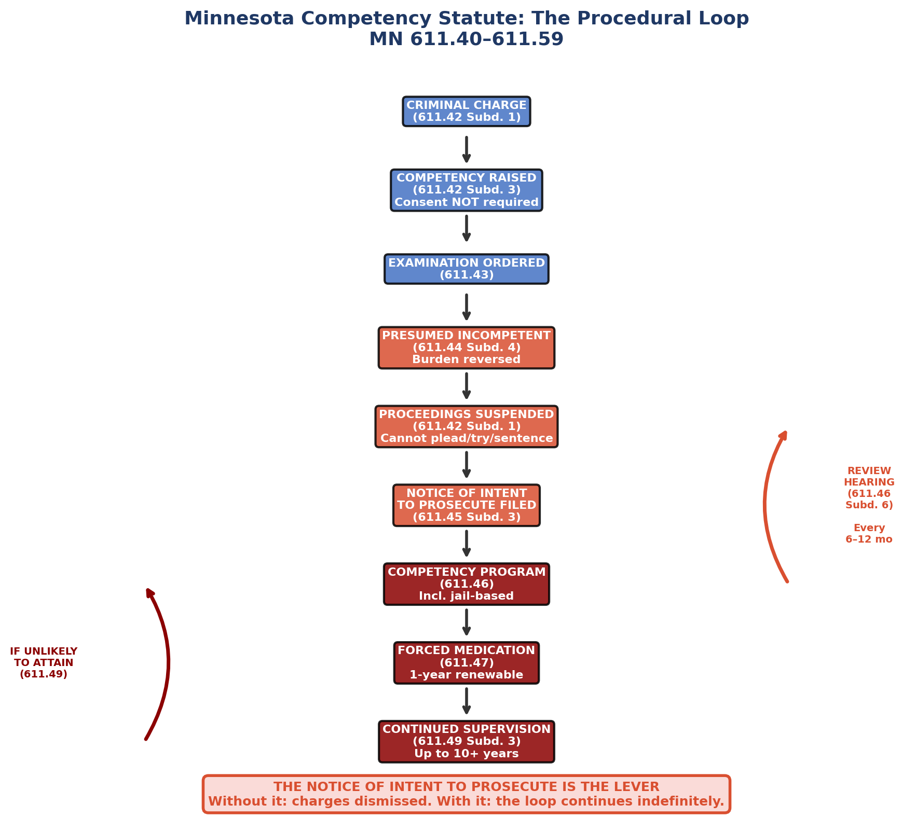

Finding 6: The Pipeline Scale — How Many People This Affects

Background
Findings 1–5 establish what the “Notice of Intent to Prosecute” is and what is wrong with 18 of them. This finding quantifies how many people the mechanism affects within the MCRO corpus.

Findings
Corpus-wide “Notice of Intent to Prosecute” inventory: 48 NIP filings exist across the corpus, covering 43 cases and 30 defendants. Filing dates range from February 23, 2017 to March 11, 2024. (See Appendix A7.)
Aspose vs. non-Aspose breakdown: Of the 48 NIP filings, 18 (37.5%) carry the Aspose producer string with fabricated creation metadata. These 18 affect 15 defendants across 18 cases. The remaining 30 (62.5%) were produced by non-Aspose tools and affect 16 defendants across 25 cases. (See Appendix A8.)
Incompetency rate: Among CR (criminal) cases with documents in the corpus, 131 of 217 (60.4%) have a “Finding of Incompetency and Order” filing. (See Appendix A6.)
Incompetency-to-NIP pipeline: 23 defendants in the corpus have BOTH a Finding of Incompetency AND a Notice of Intent to Prosecute. For 4 defendants, the NIP and incompetency finding were filed on the same day. For 6 defendants, the NIP actually preceded the formal incompetency finding in the document archive. (See Appendix A9.)

Significance
37.5% of all “Notice of Intent to Prosecute” filings in the MCRO corpus carry fabricated creation metadata. These are not peripheral documents — they are the statutory mechanism that prevents charge dismissal for defendants found incompetent. For every defendant affected, this document is the difference between freedom and continued prosecution.

Finding 7: Cross-Dimensional Overlap — The Aspose Defendants in Other Forensic Populations

Background
Prior MCRO reports have identified multiple independent forensic anomaly populations: ESolutions Development Certificate Authority digital signatures, IronPDF-generated documents, and elevated Rule 20 competency event counts. This finding examines whether the 22 Aspose defendants overlap with these other populations.

Findings
Defendant | ESolutions Sig | Incompetency Order | R20 Events
ABDINOUR ALASOW | Y | Y | Y
ALEXANDER THOMLEY |  | Y | Y
BISHARO NOOR |  | Y | Y
CARMEN GREAVES | Y | Y | Y
CASPER VUONG |  |  | Y
DENNIS BARRY | Y | Y | Y
INGRAM OYUGI |  | Y | Y
ISAAC KELLEY | Y |  | Y
JALEISHA TAYLOR | Y |  | Y
JULIET HIGGINS | Y | Y | Y
MAKIS LANE | Y |  | Y
MARVAL BARNES | Y | Y | Y
MOLLY PRICE | Y | Y | Y
PRIEST JESUS | Y |  | Y
RAMADAN CAMPBELL |  |  | Y
RASHEED RICHARDSON | Y |  | Y
RODRICK CARPENTER | Y |  | Y
SANDRA VONGSAPHAY |  | Y | Y
STEPHONE GAMMAGE | Y | Y | Y
TIA PAYNE |  | Y | Y
Travis McGIRL |  | Y | Y
WILLIAM NABORS | Y | Y | Y
Summary: 22/22 (100%) have Rule 20 competency events. 14/22 (63.6%) have ESolutions digital signatures. 14/22 (63.6%) have a Finding of Incompetency and Order. No Aspose defendant is outside the competency pipeline.
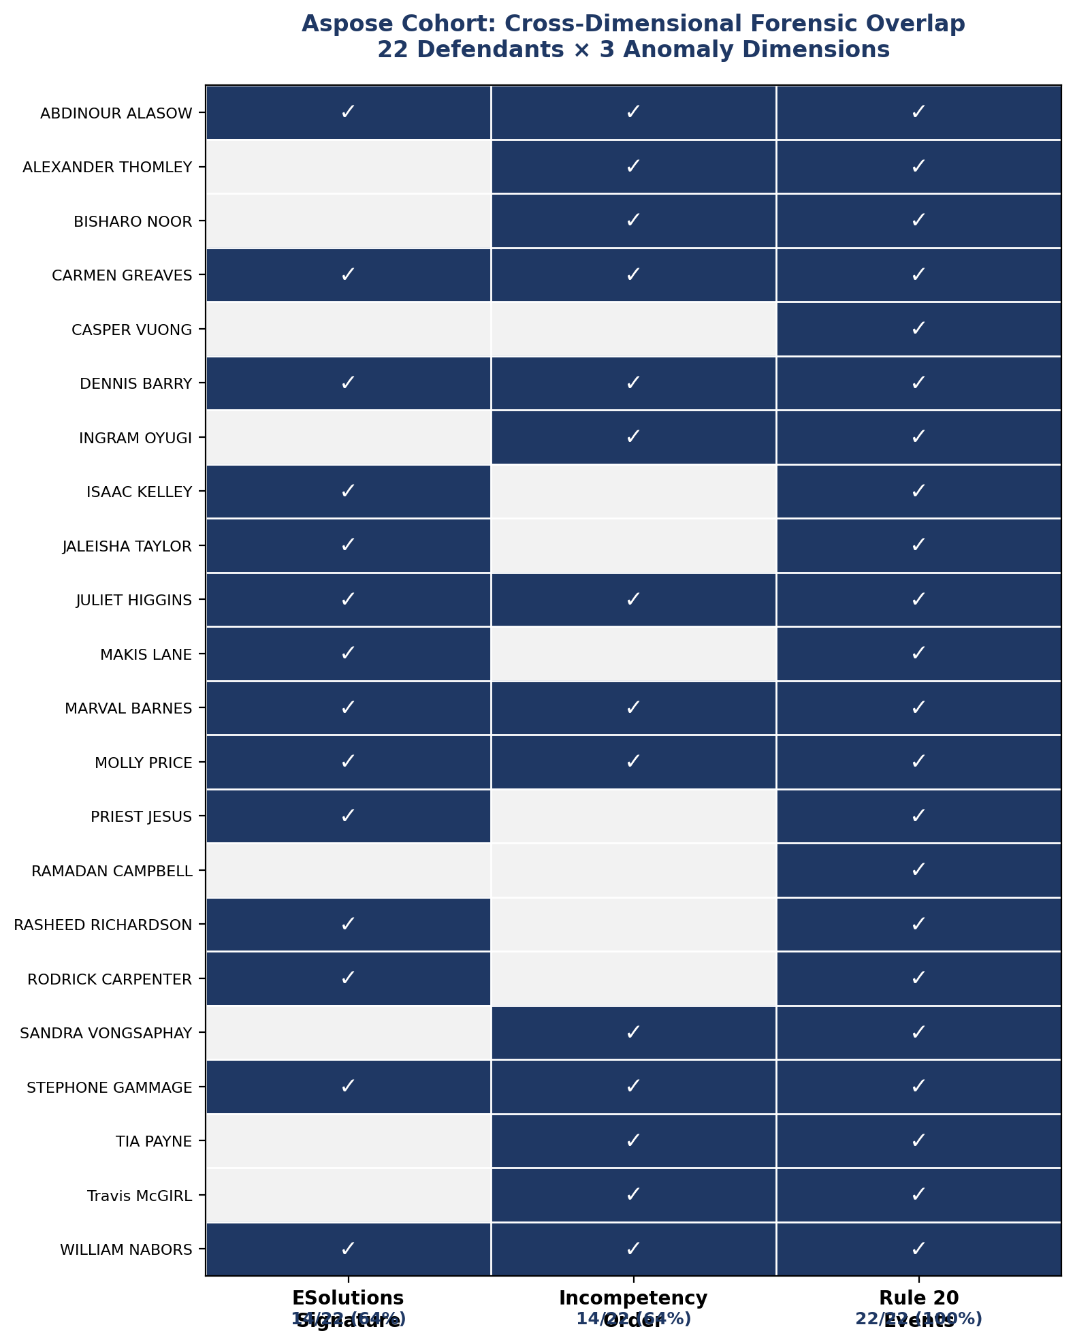

Significance
The Aspose cohort is not an isolated anomaly. Every Aspose defendant is embedded in the Rule 20 competency pipeline. The overlap with ESolutions signatures (63.6%) and incompetency orders (63.6%) indicates that the Aspose-fabricated documents exist within a broader ecosystem of forensic anomalies previously documented in this report series.

Finding 8: The iText Pipeline Confirmation

Background
The MCRO system uses iText® 7.1.16, licensed to the Minnesota Judicial Branch, to process documents through its e-filing pipeline. This processing adds the iText producer string to the document’s XMP metadata. Its presence confirms a document was processed through the official court system.

Findings
27 of 27 Aspose documents (100%) carry the iText 7.1.16 Minnesota Judicial Branch pipeline stamp. Corpus-wide, 4,148 of 4,251 documents (97.6%) carry this stamp. (See Appendix A13–A14.)

Significance
The Aspose documents were not rogue uploads, external attachments, or documents that bypassed the court system. They were processed through the same official e-filing pipeline that handles 97.6% of all documents in the corpus. Whatever process created these documents with fabricated timestamps, it fed them into the official system.

Finding 9: The Guertin Nexus — The Inventor, The Patent, The Incompetency, The Database
Background
This finding presents the timeline of the person who built the forensic database that identified the patterns documented in this report.

Findings
Date | Event
2022-03-18 | Guertin files US Patent Application 17/698,420
2022-07-18 | InfiniSet, Inc. incorporated (Delaware)
2022-11-13 | InfiniSet, Inc. registered in Minnesota
2022-12-06 | US Patent 11,577,177 granted to Matthew D. Guertin
2023-01-12 | Guertin drives to FBI office to report suspected patent infringement
2023-01-24 | Criminal complaint filed: State v. Guertin (27-CR-23-1886)
2023-01-25 | First Rule 20.01 competency evaluation ordered
2023-03-10 | First Rule 20 evaluation report
2023-07-13 | First Finding of Incompetency
2024-01-16–17 | Second Finding of Incompetency
2024-04-29–30 | Guertin downloads the 163 MCRO seed cases
2024–2025 | Guertin builds 4,251-document forensic database
2025-04-29 | Judge Hudleston orders 4th Rule 20 evaluation (26 days after competency restoration by Judge Koch)
2025-10-07 | Carpenter tells Guertin “they can do it indefinitely”
2025-11-18 | Guertin told he cannot litigate discovery issues while incompetent
Ongoing | 38+ months of Rule 20 proceedings; 23 R20/competency events; 68.8th percentile

The Meta-Finding
The person declared legally incompetent — unable to “rationally consult with counsel,” “understand the proceedings,” or “participate in the defense” under MN 611.42 — is the same person who:
• Holds US Patent 11,577,177 (adaptive media interface)
• Is CEO of InfiniSet, Inc.
• Built a PostgreSQL forensic database of 4,251 court documents across 245 cases
• Designed and deployed a dual-timestamped evidence capture system (OpenTimestamps + MITMPROXY)
• Produced 49+ forensic reports documenting anomalies in the court records
• Discovered that the filing type preventing charge dismissal — “Notice of Intent to Prosecute” — contains fabricated creation dates
And the system that declared him incompetent uses the same “Notice of Intent to Prosecute” mechanism to maintain indefinite control over defendants.

Finding 10: The Travis McGIRL Filing — The 12.1-Year Gap
Background
Travis McGIRL’s case (27-CR-20-20866) represents the single most extreme data point in the Aspose cohort.

Findings
A “Dismissal by Prosecuting Attorney” document for Travis McGIRL was filed on September 30, 2025. Its XMP creation date is September 9, 2013 — a gap of 4,404 days (12.1 years). The creation date is 5 months before the Aspose 14.2.0.0 software existed.
McGIRL’s docket reveals a 5-year journey through the competency pipeline: criminal complaint (September 29, 2020), first Rule 20 evaluation order (October 27, 2020), first Found Incompetent (February 2, 2021), Notice of Intent to Prosecute filed (February 3, 2021 — the next day), four subsequent Findings of Incompetency (August 2021, February 2022, March 2023, April 2025), and finally Dismissal by Prosecuting Attorney on September 30, 2025. (See Appendix A15–A16.)

Significance
The document that ends McGIRL’s prosecution — the dismissal — was itself produced by the same Aspose system that generated the “Notice of Intent to Prosecute” documents that kept other defendants’ cases alive. A dismissal filed in 2025 claims to have been created in 2013. The document type is itself significant: it represents the end of a prosecution that was enabled to continue by a “Notice of Intent to Prosecute” — the same filing type that constitutes 66.7% of the Aspose cohort.

Connecting Context
McGIRL’s case is a complete lifecycle: charge → incompetency → NIP filed (next day) → four more incompetency findings over 4 years → dismissal. The entry mechanism (NIP) and the exit mechanism (dismissal) both carry Aspose-fabricated creation dates. The system that kept him in the pipeline and the system that released him from it used the same document generation process.

LIMITATIONS AND ALTERNATIVE EXPLANATIONS
The following alternative explanations have been considered:
Template reuse: It is common practice to create documents from templates. However, template reuse explains identical formatting, not identical XMP creation timestamps across documents for different defendants filed years apart. The XMP create date reflects when the specific file was created, not when its template was designed.
Metadata modification: PDF metadata can be modified after creation. However, modification would require deliberate action and would itself raise questions about document integrity. Additionally, the iText pipeline stamp confirms these documents passed through the official court e-filing system.
Clock drift or timezone errors: Clock drift accounts for seconds or minutes of discrepancy, not 168 days (the gap between the earliest creation date and the software release). Timezone errors account for at most 24 hours. Neither explains pre-release creation dates.
Software version misidentification: The producer string “Aspose.Words for .NET 14.2.0.0” is embedded by the software itself during document creation. Aspose does not allow users to arbitrarily set this value. A different version would produce a different string.
Corpus selection bias: The MCRO corpus was assembled from public court records for Fourth Judicial District cases. It is not a random sample of all Minnesota courts. The incompetency rates, NIP frequencies, and other pipeline statistics apply to the corpus population and should not be extrapolated without additional data.

RECOMMENDATIONS FOR INDEPENDENT VERIFICATION
1. Obtain original pre-MCRO versions of the 27 Aspose documents from the court’s internal document management system (Tyler Technologies Odyssey). Compare their XMP metadata against the MCRO-served versions.
2. Request the Aspose.Words license records from the Hennepin County Attorney’s Office or the Fourth Judicial District to determine which entity holds the Aspose license that produced these documents.
3. Verify the Aspose.Words 14.2.0.0 release date from Aspose’s public release history and NuGet package archives.
4. Query the court’s document management system for all “Notice of Intent to Prosecute” filings district-wide (not limited to the MCRO corpus) and examine their creation metadata for the same frozen timestamp patterns.
5. Retain a credentialed digital forensics examiner (CFCE, EnCE, or equivalent) to independently verify the PDF metadata findings using the SHA256-anchored evidence chain.
6. Review the OpenTimestamps blockchain anchoring for the complete corpus to confirm that the examined files have not been modified since anchoring.

APPENDIX | REPRODUCIBLE SQL QUERIES
All queries below are SELECT-only and can be executed against the MCRO forensic database (Supabase project ibfmjtwahkwqzcmeyqii, region us-west-2).

A1 — Aspose Cohort Universe
SELECT COUNT(*) AS total_docs,
COUNT(DISTINCT case_id) AS distinct_cases,
COUNT(DISTINCT cluster_id) AS distinct_clusters,
COUNT(DISTINCT cluster_name) AS distinct_defendants,
COUNT(DISTINCT filing_type) AS distinct_filing_types,
MIN(filing_date) AS earliest_filing,
MAX(filing_date) AS latest_filing,
MIN(metadata__xmp_create_date) AS earliest_create,
MAX(metadata__xmp_create_date) AS latest_create
FROM children
WHERE metadata__xmp_producer ILIKE '%Aspose%';

A2 — Frozen Timestamp Clusters
SELECT date_trunc('minute', metadata__xmp_create_date) AS frozen_ts,
COUNT(*) AS doc_count,
COUNT(DISTINCT cluster_id) AS defendant_count,
COUNT(DISTINCT case_id) AS case_count,
array_agg(DISTINCT filing_type ORDER BY filing_type) AS filing_types,
MIN(filing_date) AS earliest_filing,
MAX(filing_date) AS latest_filing,
MAX(filing_date) - MIN(filing_date) AS filing_span_days
FROM children
WHERE metadata__xmp_producer ILIKE '%Aspose%'
GROUP BY date_trunc('minute', metadata__xmp_create_date)
HAVING COUNT(*) >= 2
ORDER BY frozen_ts ASC;

A3 — Full Aspose Cohort with Gap Calculations
SELECT cluster_name, case_id, filing_type, filing_date,
metadata__xmp_create_date,
filing_date - metadata__xmp_create_date::date AS gap_days,
filename
FROM children
WHERE metadata__xmp_producer ILIKE '%Aspose%'
ORDER BY metadata__xmp_create_date ASC, filing_date ASC;

A6 — CR Incompetency Rate
SELECT
COUNT(DISTINCT c.case_id)
FILTER (WHERE c.filing_type = 'Finding of Incompetency and Order')
AS cases_with_incompetency,
COUNT(DISTINCT c.case_id) AS total_cases_with_docs,
ROUND(COUNT(DISTINCT c.case_id)
FILTER (WHERE c.filing_type = 'Finding of Incompetency and Order')::numeric
/ NULLIF(COUNT(DISTINCT c.case_id), 0) * 100, 1) AS incompetency_pct
FROM children c
WHERE c.case_type ILIKE '%CR%';

A7 — Notice of Intent to Prosecute: Corpus-Wide
SELECT COUNT(*) AS total_notices,
COUNT(DISTINCT case_id) AS distinct_cases,
COUNT(DISTINCT cluster_id) AS distinct_defendants,
MIN(filing_date) AS earliest,
MAX(filing_date) AS latest
FROM children
WHERE filing_type = 'Notice of Intent to Prosecute';

A8 — NIP: Aspose vs. Non-Aspose Breakdown
SELECT
CASE WHEN metadata__xmp_producer ILIKE '%Aspose%'
THEN 'Aspose' ELSE 'Non-Aspose' END AS producer_type,
COUNT(*) AS doc_count,
COUNT(DISTINCT case_id) AS cases,
COUNT(DISTINCT cluster_id) AS defendants
FROM children
WHERE filing_type = 'Notice of Intent to Prosecute'
GROUP BY 1;

A9 — Incompetency-to-NIP Pipeline
SELECT c1.cluster_id, c1.cluster_name,
MIN(c1.filing_date) AS first_incompetency,
MIN(c2.filing_date) AS first_notice_intent,
MIN(c2.filing_date) - MIN(c1.filing_date) AS days_between
FROM children c1
JOIN children c2 ON c1.cluster_id = c2.cluster_id
WHERE c1.filing_type = 'Finding of Incompetency and Order'
AND c2.filing_type = 'Notice of Intent to Prosecute'
GROUP BY c1.cluster_id, c1.cluster_name
ORDER BY days_between ASC;

A11 — Cross-Dimensional Overlap
WITH aspose_clusters AS (
SELECT DISTINCT cluster_id, cluster_name
FROM children WHERE metadata__xmp_producer ILIKE '%Aspose%'
),
esolutions AS (
SELECT DISTINCT c.cluster_id
FROM children_signatures_full_report s
JOIN children c ON c.evidence_uid = s.evidence_uid
WHERE s.signer_name ILIKE '%ESolutions%'
),
incompetency AS (
SELECT DISTINCT cluster_id FROM children
WHERE filing_type = 'Finding of Incompetency and Order'
),
r20_events AS (
SELECT DISTINCT cr.cluster_id
FROM parents_case_events pce
JOIN parents p ON pce.case_uid = p.case_uid
JOIN case_registry cr ON cr.case_uid = p.case_uid
WHERE pce.event_name ILIKE '%Rule 20%'
OR pce.event_name ILIKE '%competency%'
)
SELECT a.cluster_name,
CASE WHEN e.cluster_id IS NOT NULL THEN 'Y' ELSE '' END AS esolutions,
CASE WHEN i.cluster_id IS NOT NULL THEN 'Y' ELSE '' END AS incompetency,
CASE WHEN r.cluster_id IS NOT NULL THEN 'Y' ELSE '' END AS r20_events
FROM aspose_clusters a
LEFT JOIN esolutions e ON a.cluster_id = e.cluster_id
LEFT JOIN incompetency i ON a.cluster_id = i.cluster_id
LEFT JOIN r20_events r ON a.cluster_id = r.cluster_id
ORDER BY a.cluster_name;

A13 — iText Pipeline on Aspose Documents
SELECT
COUNT(*) FILTER (WHERE metadata__xmp_producer ILIKE '%iText%7.1.16%')
AS itext_stamped,
COUNT(*) AS total_aspose
FROM children
WHERE metadata__xmp_producer ILIKE '%Aspose%';

A14 — Corpus-Wide iText Coverage
SELECT
COUNT(*) FILTER (WHERE metadata__xmp_producer ILIKE '%iText%7.1.16%')
AS itext_total,
COUNT(*) AS corpus_total,
ROUND(COUNT(*) FILTER
(WHERE metadata__xmp_producer ILIKE '%iText%7.1.16%')::numeric
/ COUNT(*) * 100, 1) AS pct
FROM children;

A15 — McGIRL Filing Details
SELECT filename, case_id, cluster_name, filing_type, filing_date,
metadata__xmp_create_date,
filing_date - metadata__xmp_create_date::date AS gap_days
FROM children
WHERE metadata__xmp_producer ILIKE '%Aspose%'
AND cluster_name ILIKE '%McGIRL%';

A16 — McGIRL Full Docket
SELECT pce.event_json__date AS event_date, pce.event_name
FROM parents_case_events pce
JOIN parents p ON pce.case_uid = p.case_uid
WHERE p.case_id = '27-CR-20-20866'
ORDER BY pce.event_json__date ASC, pce.event_index DESC;

